
ANNUAL REPORT 2018 – 2019
SAVING TIGER SOCIETY
Registration No: S/1L/87726
Registered Office: Abhilasha Asg – 58A/2 N C Chowdhury, Kolkata 700 042.
E-mail: savingtiger.indrajit@gmail.com.
Website: www.savingtiger.org

MISSION STATEMENT

SAVING TIGER members believe Wildlife is meant to represent the Environment in its totality - Mammals, Reptiles, Amphibians, Birds, Trees, Plants and Human Life.
SAVING TIGER will work towards the conservation of forests and wildlife with particular attention to our National animal, the Tiger. The Society will also create awareness about environment protection among the villagers living in areas adjoining the forest areas where the Society will simultaneously work for overall improvement in the life of these people.

PLAN OF ACTION -

Awareness campaigns in villages around the periphery of forests on “Human-Wild Animal Conflict”.

Tours & Nature walk programs to educate urban citizens about the fragile eco-system and the cycle of nature and the need for joint action on conservation.

Rescue work and veterinary services for wildlife in danger.

Prevention of Poaching.

Set-up a self sustainable model village in a chosen jungle area, keeping agriculture as the main economic activity to demonstrate:
a) Reduction of dependence on forest for income
b) Make villagers the guardians of local wild-life
c) Set-up free school for village kids for proper education and awareness.
d) Awareness campaigning on different nature related subject.

Organize training courses, workshops and conferences on concerns of nature and wild-life protection for students and public.
Support forest staff with useful equipments and trainings.
Medical camps for the villagers and forest staff along with their family.

ORGANISATION AT A GLANCE

SAVING TIGER is registered under the West Bengal Registration of Societies Act on ………………… as a Non-Profit, non-government organization which will function as a society governed by the regulations of the West Bengal Registration of Societies Act. Registration No - S/1L/87726

Sl. No. | Name | Address | Profession | Membership Status | Post
1 | Indrajit Sengupta | Abhilasha Asg – 58A/2 N.C Chowdhury Road, Kolkata 700 042. | Business | Life Member | President
2 | Anupa Roy | Abhilasha Asg – 58A/2 N.C Chowdhury Road, Kolkata 700 042. | Business | Life Member | Vice-President
3 | Gurupada Bhanja | Vill-Nafargunj,Block-Basanti,Dist-South 24(P),West-Bengal. | Service | Life Member | Secretary
4 | Anadi Nath Bag | Konnogar, Hoogly,  712235 | Service | Ordinary  Member | Treasurer
5 | Bibek Mondal | Gairkata,Jalpaiguri,West-Bengal.  735212 | Consultant | Life Member | Executive Member
6 | Indranil Sengupta | 31/1 Sree Gopal Mallick Road,Kolkata-700057. | Service | Ordinary Member | Executive Member
7 | Tapasi Sengupta | 31/1 Sree Gopal Mallick Road,Kolkata-700057. | Professional | Ordinary Member | Executive Member

The above members are the core group of persons who signed the Memorandum of Association of the Society. Membership of “SAVING TIGER” is open to all individuals who love nature, wild-life and are concerned about the human assault on nature. The Managing Committee of the Society however reserves the right to select new members.

ACTIVITIES OF THE year 2018-2019

ANIMAL SQUAD TEAMS FOR PENCH TIGER RESERVE, M.P

Animal Squad teams is an another project of Saving Tiger Society, which is running at Pench Tiger Reserve, M.P. from 2016. We choose some sensitive villages which are situated at the edge of Pench Tiger Reserve. Some the herbivore animals come out in night time and destroys the agriculture fields of the villagers. And for that reason electrocutions was happen so much, they kill the animals. So in that issue we start this project as the teams do patrol from evening to morning with search lights, drums, crackers and a recording of a tiger sound so that the animals does not come out as they know there is something happen. From last two years we are working on it and the result is very effective.

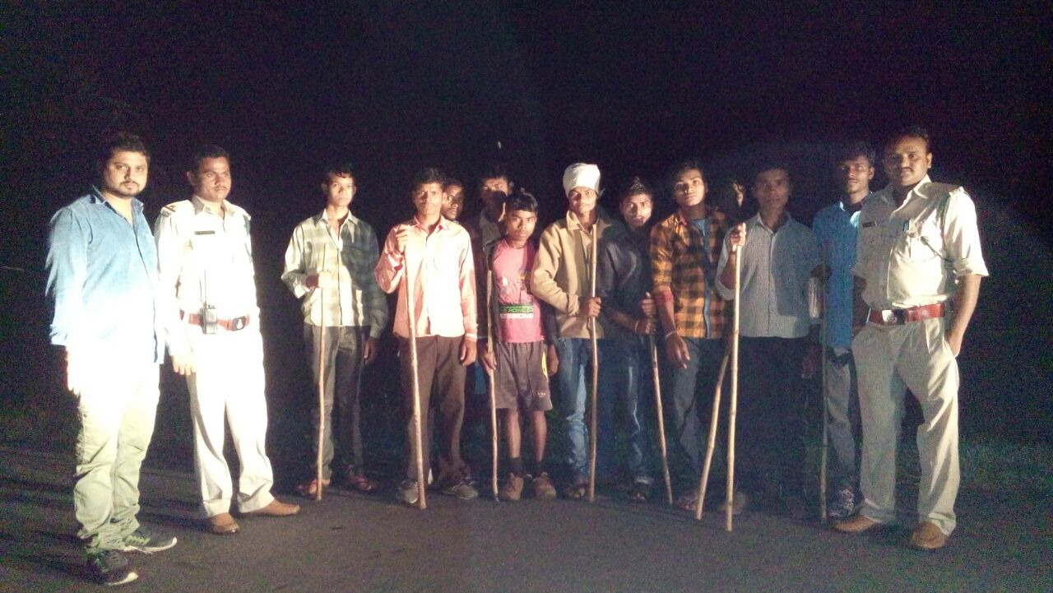

NATURE EDUCATION CLASS FOR THE SCHOOL STUDENTS OF GHATKOKA BUFFER ZONE, PENCH TIGER RESERVE

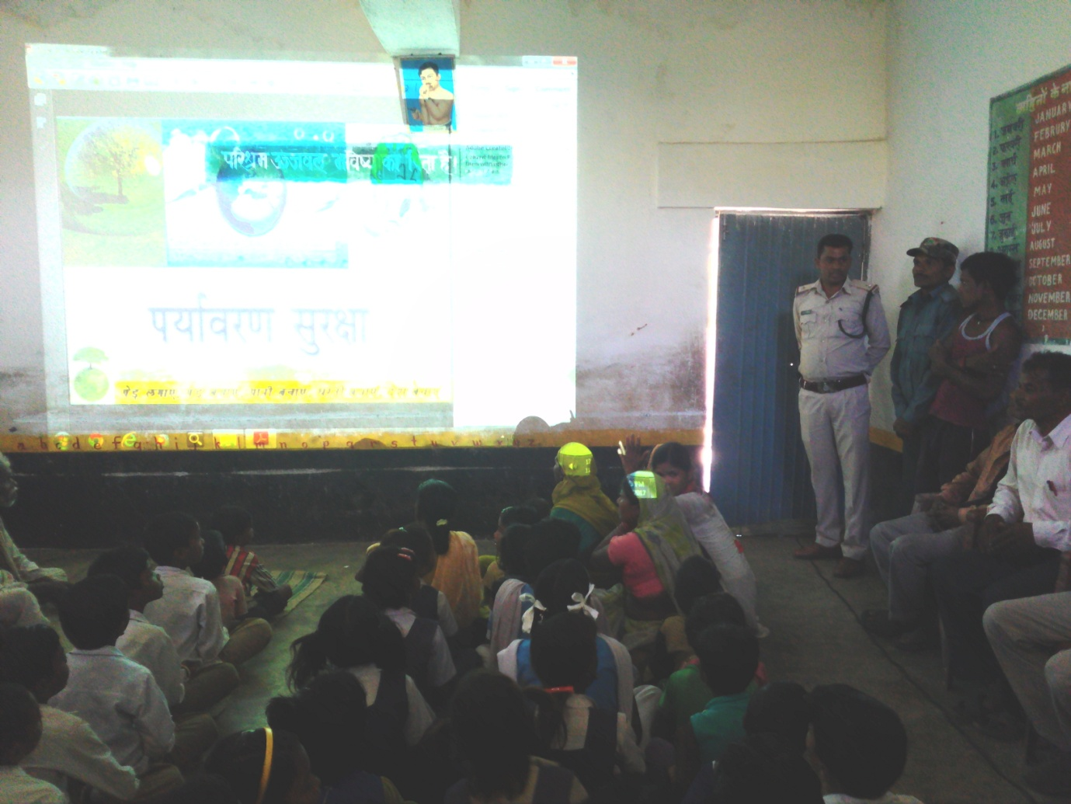
This is also a very vital project to protect our mother nature, as we know that education has the power to keep you in a right way and in the forest areas education is the main key to make people understand the value of our forest and wildlife. So keeping this in mind we have started this project from 2017 in six different schools at Ghatkhoka Range and Gumtara Range. This is a 3 year pilot project. We all know that if we educate or aware the school kids about nature then they become the future warriors of our mother nature and they have the ability to make their parents understand about the value of our nature. We are doing this project through power point presentation of nature, wildlife & superstitions and different kind of wildlife movies. In one year we get some positive results from students and we are hoping for more. Weekly we take the classes in every school and after every 3 months we take the students for a field visit.

3rd PHASE OF WELL WORK (BOUNDARY WALL FOR THE SENSITIVE WELLS) AT PENCH TIGER RESERVE

Base on our survey report and as requested from the FD of Pench Tiger Reserve, we the Saving Tiger and Tiger Awareness are build up the boundary walls of the sensitive wells of buffer zone of that reserve. These wells are situated at the buffer zone and at night time many animals are fell down into these wells and died.
It’s our 3rd phase of making the boundary walls of the sensitive wells of the buffer zone. And we build up 10 more boundary walls in the month February 2018.
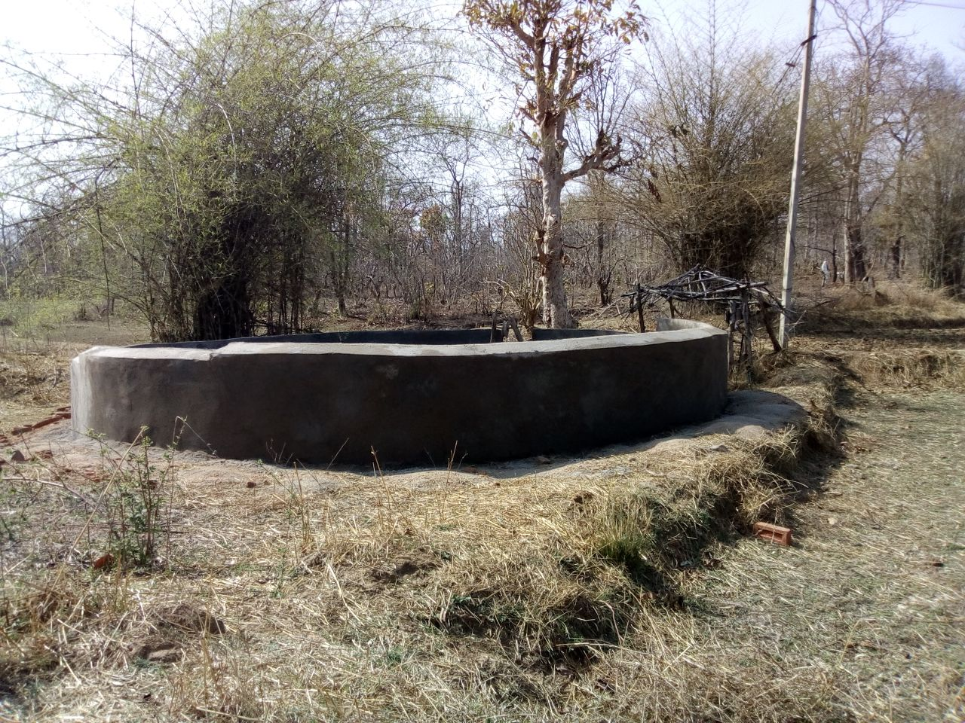

HEALTH CHECK UP CAMPS FOR THE VILLAGERS OF SUNDARBAN

Health is the biggest asset of a human. In sundarban it is a very sensitive issue for the villagers, they did not have any proper medical treatment. So in that issue we the Saving Tiger Society and Tiger awareness organized health check up camp on 16th March 2018 for the villagers and our tiger squad team members thrice in a year. We can give free treatment on special issues and also give free medicines. And for the Tiger Squad teams we can provide a medical kit with common medicines.
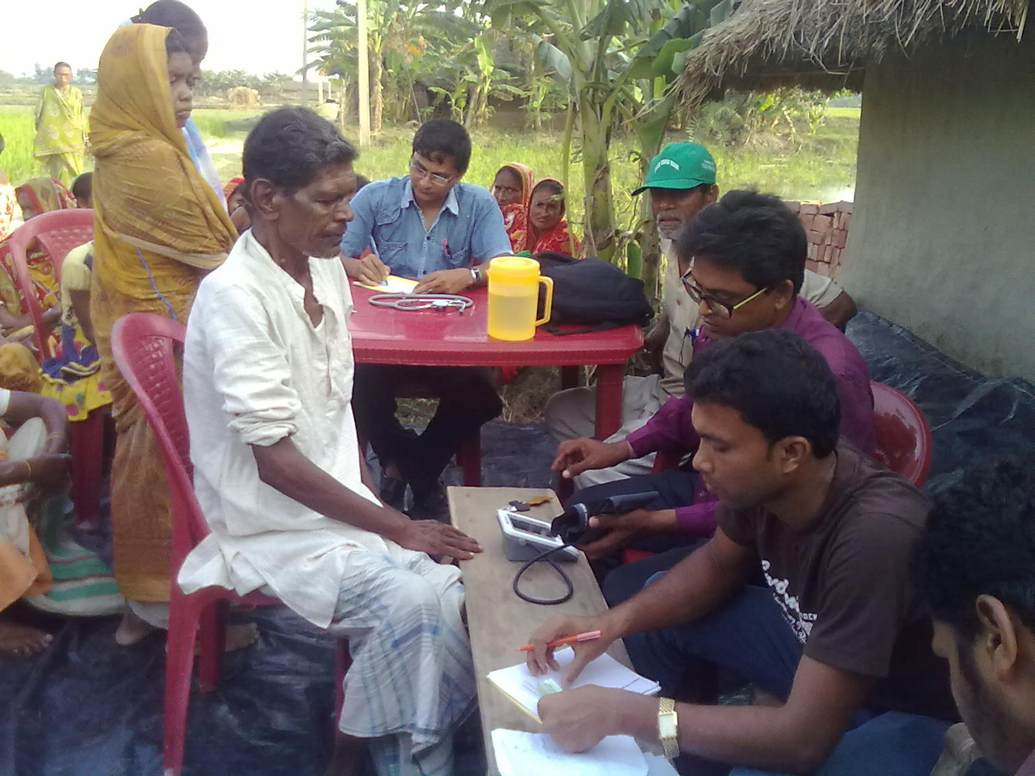

GLOBAL TIGER DAY CELEBRATION AT PENCH TIGER RESERVE, M.P

Tigers are an integral part of our earth ecosystem. It is not that they need us to save them but we need them to save our planet and ourselves. We do believe that if we don’t take the “save our tiger” initiative seriously now, it will not be long before we end up with a “save ourselves” initiative. So if we want our children to enjoy a beautiful planet with clean and healthy environment to grow up in then – Let the Tiger Live!! So in this connection every year we are celebrate this day on 29th July with a great pomp with students, naturalist, guides, local villagers and forest staffs, so this year we have celebrated this day with the numbers of peoples 1400 at Pench Tiger Reserve, Madhya Pradesh.

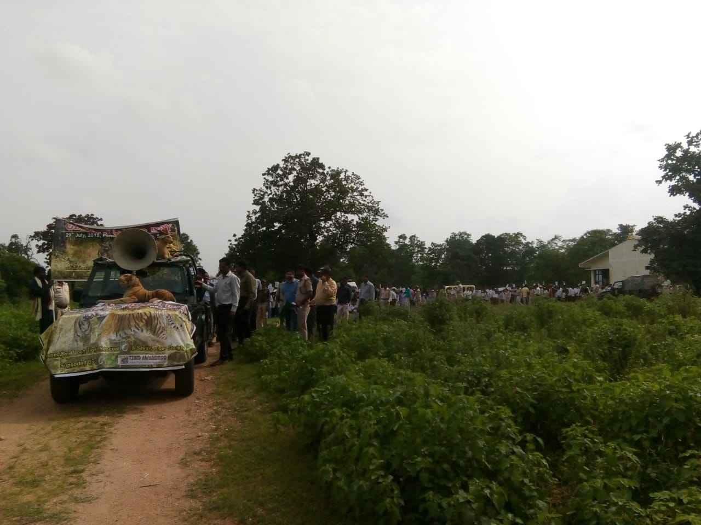

WILDLIFE WEEK CELEBRATION AT NAFARGANJ NILKANTHAPUR VIDYAPITH – SUNDARBAN

Forest and Wildlife are an integral part of our earth’s ecosystem. It is not that they need us to save them but we need them to save our planet and ourselves. Like every year this year we also have celebrated this week from 2nd October to 8th October 2019 with the students and teachers of Nilkanthapur Vidyapith, Local Peoples & social activists to create awareness and spreading the right message to the peoples about the importance of wildlife. If we want our children to enjoy a beautiful planet with clean and healthy environment to grow up in then – lets other live freely. We have celebrated this day with the school students on 2nd October 2018.

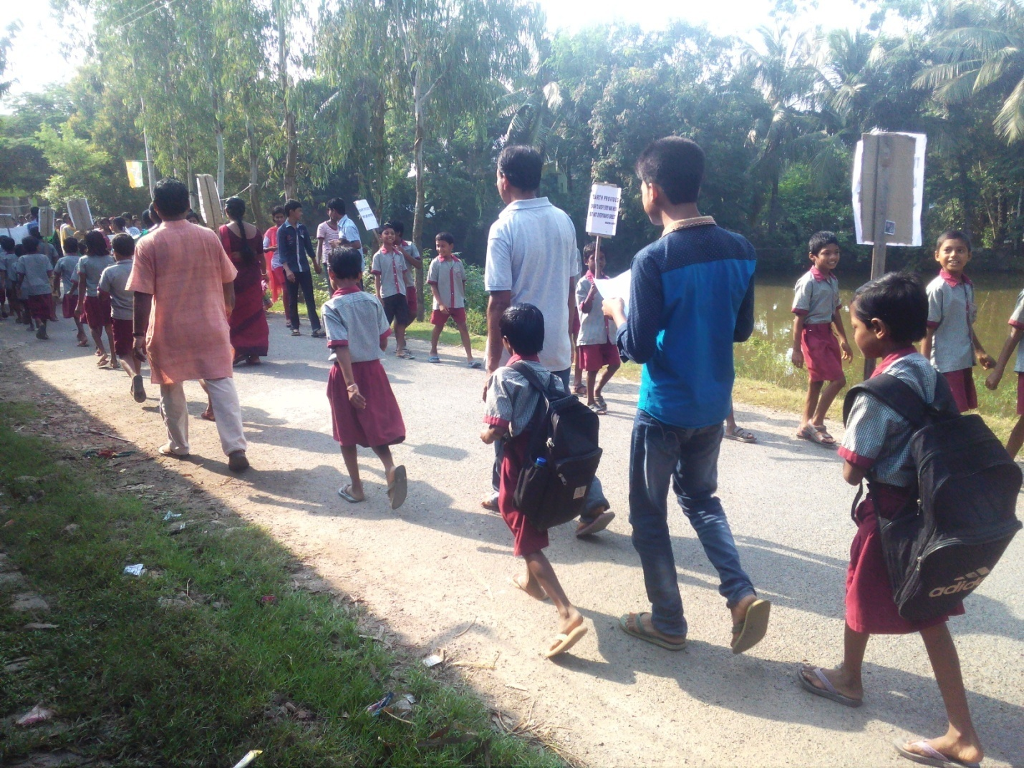

WILDLIFE WEEK CELEBRATION AT NAFARGANJ SUNRISE NATURE MODEL SCHOOL – SUNDARBAN

Forest and Wildlife are an integral part of our earth’s ecosystem. It is not that they need us to save them but we need them to save our planet and ourselves. Like every year this year we also have celebrated this week with the students and teachers of Nafarganj Sunrise Nature Model School to create awareness and spreading the right message to the peoples about the importance of wildlife. If we want our children to enjoy a beautiful planet with clean and healthy environment to grow up in then – lets other live freely. We have celebrated this day with our school students on 5th October at our school premises.

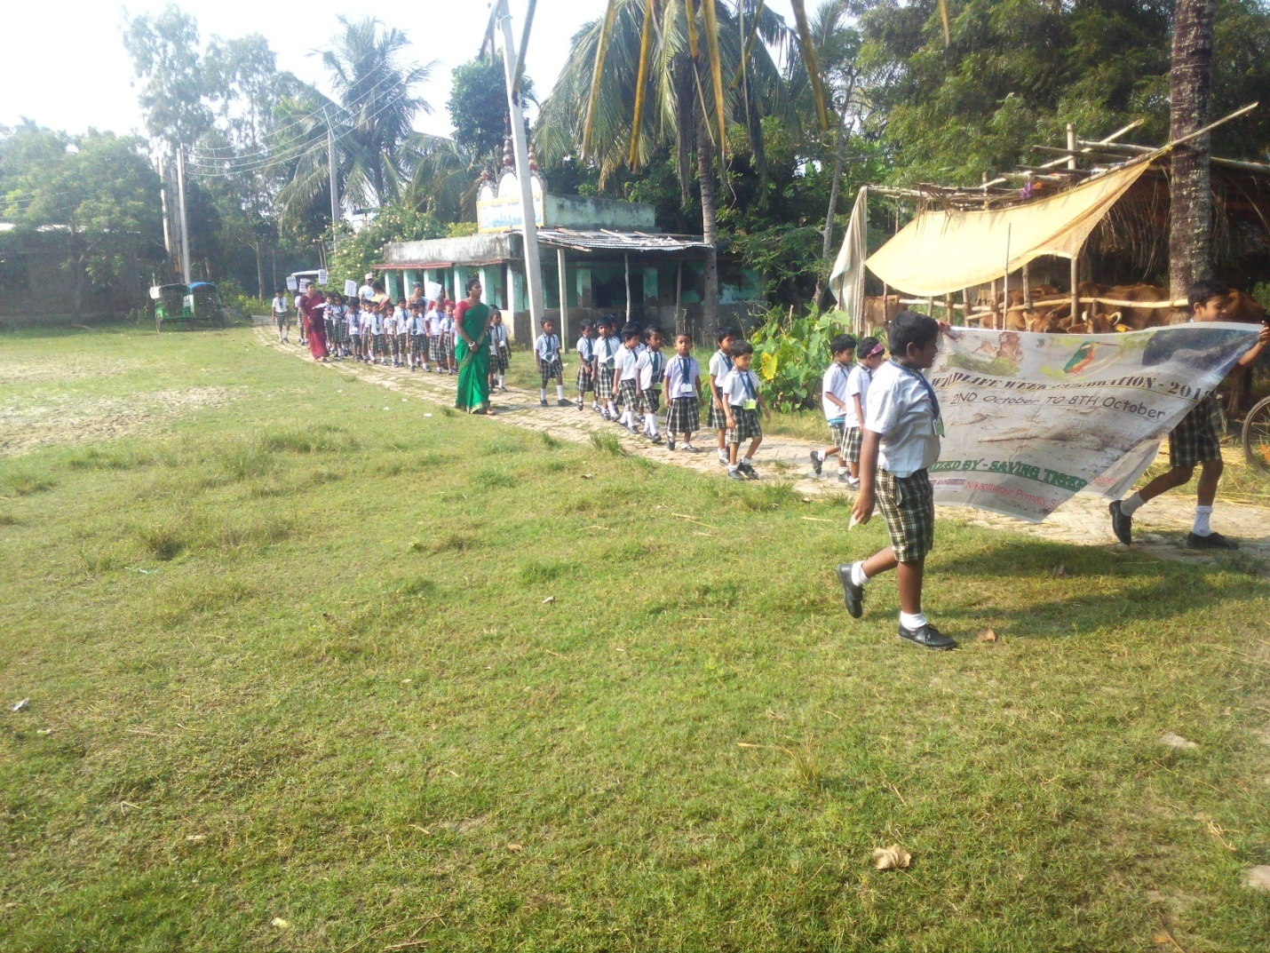

A DAY LONG SNAKE IDENTIFICATION TRAINING FOR THE RESCUERS OF KOLKATA AND SUNDARBAN – SUNDARBAN

Snake is a big threat to human as we think that, cause we have too much misconceptions and myths towards snakes from childhood so for this if we see any snake we are trying to kill it at any cost we do not want to understand the species. Rescuers are doing a very vital job to conserve and protect snakes from every threats so in this connection on this wildlife week we have organized a day long snake identification training for the rescuers of Kolkata and sundarban, as in both places there are so many rescuers those who are involved in the rescue work. We also distribute certificate to the participants. So in this connection we have done this workshop with 15 participants on 6th October at our school.

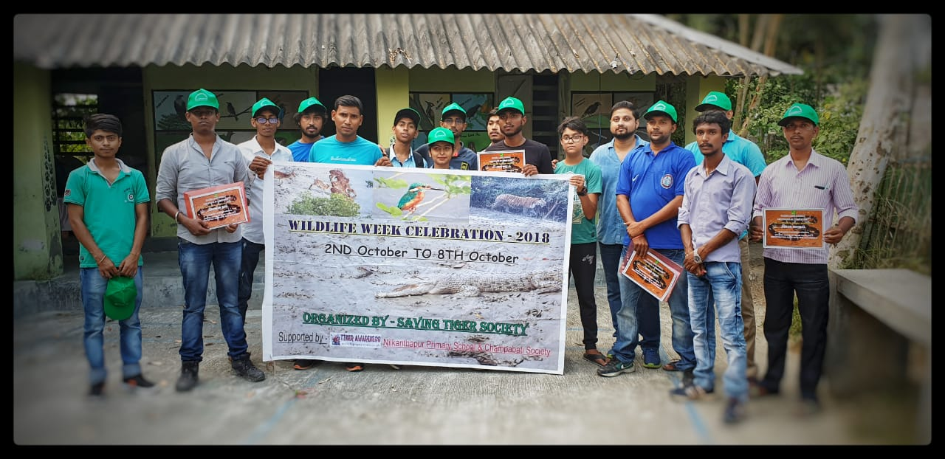

2 DAY LONG SNAKE IDENTIFICATION AND HANDLING TRAINING ALONG WITH SURVIVAL TRAINING FOR THE RESCUERS OF KOLKATA AND SUNDARBAN - SUNDARBAN

The participants in our first training workshop have requested us to organize a 2 day long advance training workshop on snakes, so in this connection we have organized a 2 day long advanced snake identification and handling training along with bite management workshop for them. We also gave a session on survival training to them. Rescuers are doing a very vital job to conserve and protect snakes from every threat also the rescuers save the human lives from snakes and snakes bites too. After our workshop we provided certificate to them along with snake hook to all the participants. We have done this 2day long training workshop on December 8th and 9th 2018.

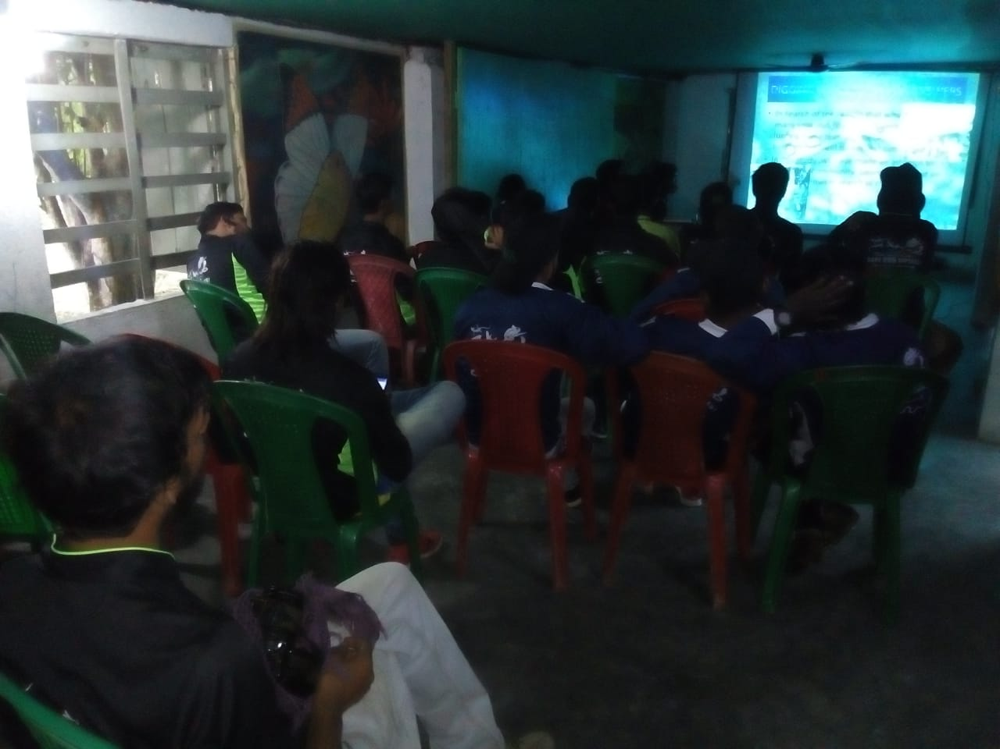
3rd PHASE OF SOLAR LIGHT POST INSTALING PROGRAM AT GOSABA AREA – SUNDARBAN

Lights – is the big issue of village areas, and the villages those which are situated in the forest area its very much imported thing. When the evening comes the villagers of these villages are covered them in their houses, no light there is no life, so on that issue we the Saving Tiger Society have install and working on our 3rd phase of solar light posts at Gosaba villages. The lights we have install at the village border areas, so that they can use the roads for their communications and in night time there are some venomous snakes are roamed in those areas so the villagers can aware and they can see the road clearly. Animal straying also become less for the lights. It’s very helpful for the villagers.



WILDLIFE DAY CELEBRATION AT DIAMOND HARBOUR AND PURULIA – WEST BENGAL

Like every year we the Saving Tiger Society have celebrated this day on 3rd march 2019 with the school students, teachers, local peoples, forest staffs and social activist. This year we have celebrated this day in two places – 1. Diamiond Harbour 2. Puruliya
In the boat places we have a good day long program with awareness programs along with plastic waste collection, tree plantation, sit and draw competition, quiz competition and screening of documentary films to the students to create a social awareness in an entertaining way.

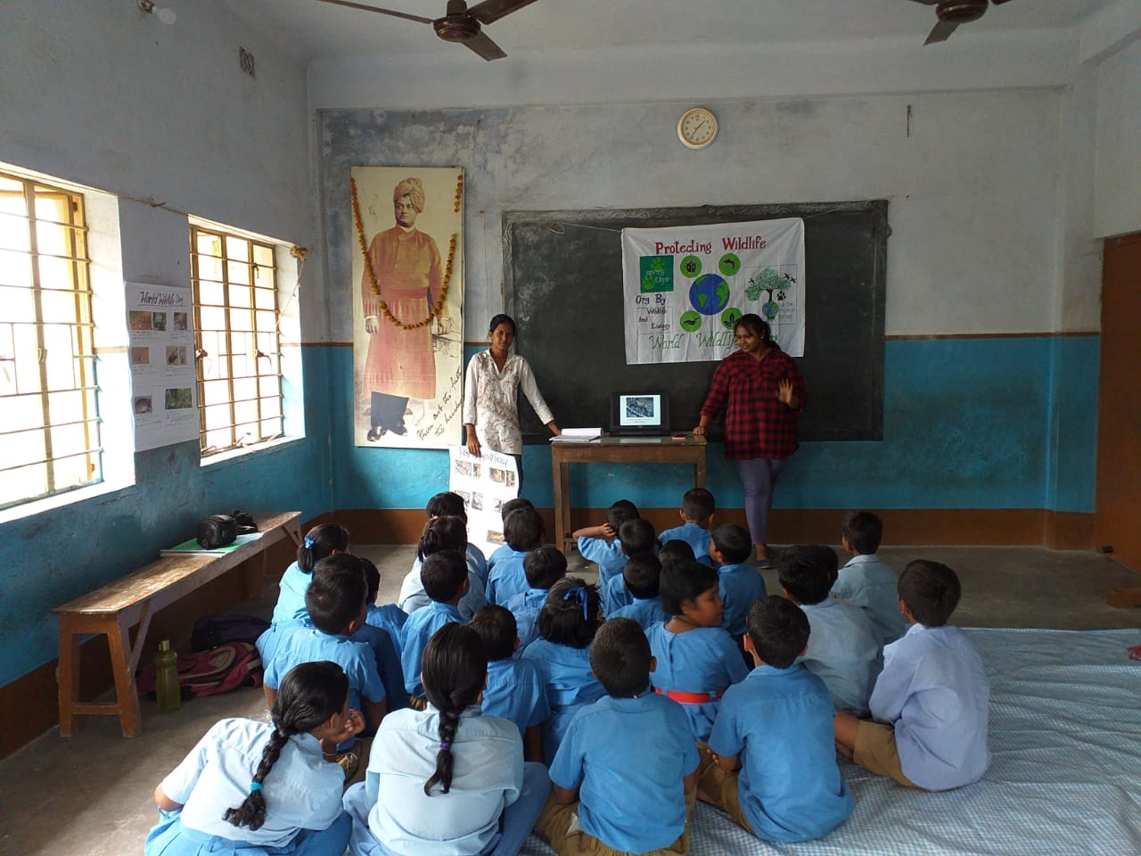

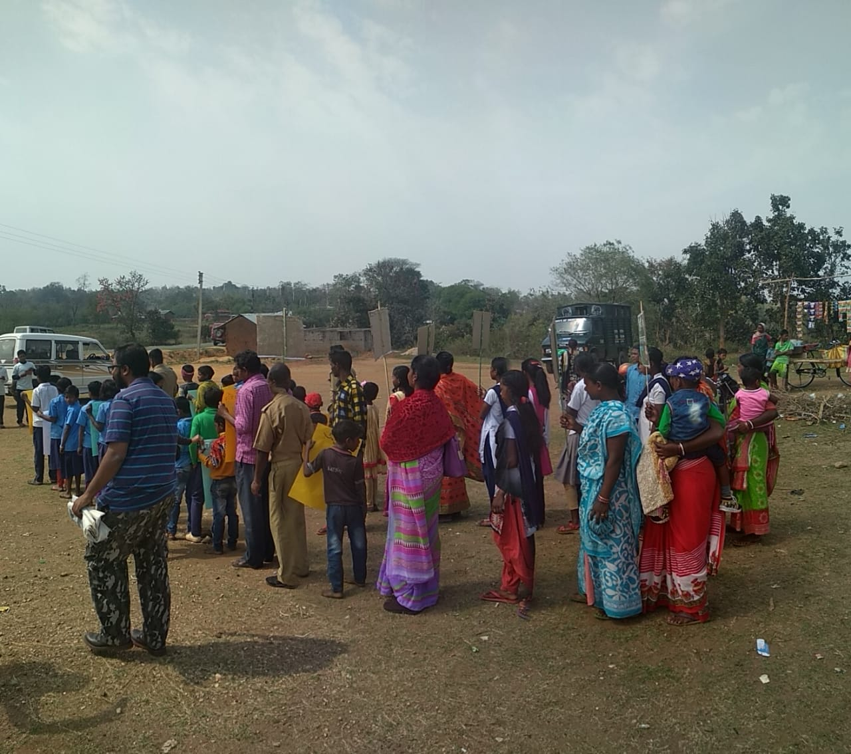

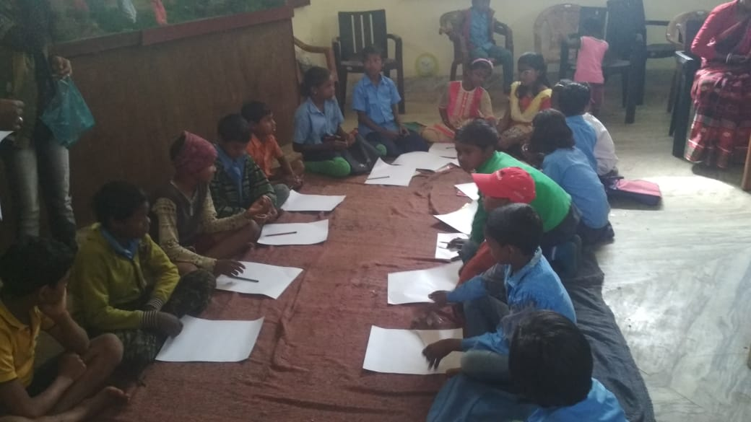

PROPOSED PLAN OF ACTION 2019 - 2020

Saving Tiger has had another fulfilling and fruitful year of events and programs. Our work has been recognized and appreciated and we are proud to say that we have received positive feedback from all those we have associated with.
We, at Saving Tiger, aim to carry on working zealously and with the same passion, enthusiasm and hard work that we have shown so far. With this goal in mind and with the aim to make the forests a safer place for our wildlife, Saving Tiger has some ambitious plans for the years ahead.

➢ To give sustainable alternative means of income to the people in the Sunderbans, Pench and Orang Tiger Reserve. Saving Tiger has already made inroads in providing support and guidance to the villages in Sunderbans and Pench and are working closely with the Forest Department and locals to create a better life to the people there. This plan will be taken further so as to minimize risks to the people and to safe guard the wildlife in the delta.

➢ We have a special plan to start camps on Education and Awareness in the forest areas of whole North Bengal, Sundarban and M.P. Because we all know Education and Awareness are the two main powerful weapons to save our Mother Nature. We are looking to start these awareness camps in all the adjoining forest areas of M.P and Sundarban, Especially we will target schools.

➢ In Sundarbans & Pench T.R, Saving Tiger is working in conjunction with the Forest department to set up programs for training for the forest guards.

➢ We are looking to introduce Dog Squads for the protection purpose and to minimize threats to wild animals for M.P Forest Dept and in West Bengal Forest Department.

➢ There are plans wherein Saving Tiger will participate in the implementation of tracking and documenting the number of wildlife and the various species present in the forests of Sundarbans and M.P Forests with special emphasis on tiger, leopards, elephant and other wild species that are being poached aggressively from this area.

Thank You

